**Pre-Registration Document Handler Performance Testing**

**Test Summary:**

|  |  |
| --- | --- |
| Kernel Request | Document Handler |
| Base URL | https://integ.mosip.io |
| Execution Window | 2019/01/11 12:40 PM IST to 2019/01/11 01:10 PM IST |
| Maximum User Load | 100 |
| Tool Used | Jmeter |

**APIs transaction Summary:**

|  |  |  |  |  |  |  |  |
| --- | --- | --- | --- | --- | --- | --- | --- |
| Label | #Sample | Average | 90% line(ms) | Min(ms) | Max(ms) | Error% | Throughput/Sec |
| POA Document Upload | 8774 | 2328 | 4461 | 305 | 46052 | 0.23% | 3.92 |
| POI Document Upload | 8747 | 2369 | 4511 | 295 | 93847 | 0.13% | 3.90 |
| Copy uploaded document | 8736 | 1771 | 3608 | 151 | 45649 | 35.81% | 3.92 |
| Delete document by document Id | 8719 | 1323 | 3448 | 0 | 119823 | 0.07% | 3.92 |
| Delete all documents by pre-registration Id | 8700 | 1355 | 3448 | 151 | 93528 | 0.09% | 3.92 |

Test Observations:

Copy uploaded document from previous PreRegID to the next PreRegID was failed 35.81% with internal server error.

Response Times Over Time

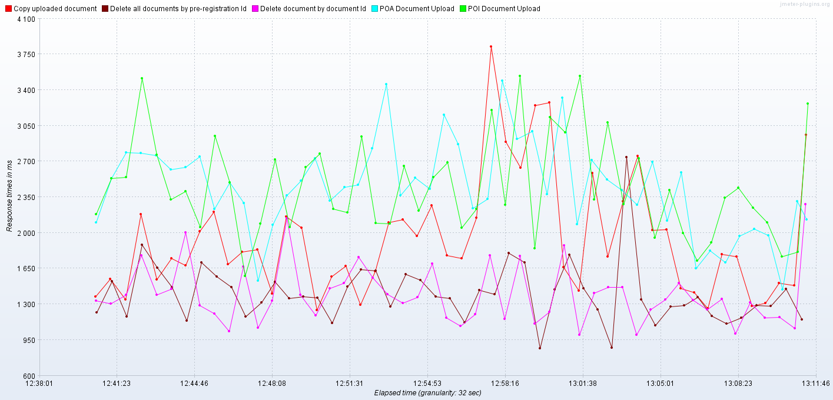

Transactions per Second

